Patient Red Folders - Folder ‘A’ Start here

- Red folders to be kept in patient’s bedroom or locker.
- Work through each section, it’s easy I promise.
- You can do this with your patient during a 1:1.

Patient Red Folders - Folder ‘B’ PILL

- Commonly used Patient Information Leaflets.
More available under choice and medication section on focus
- Don’t be the person who uses the last copy without making more, no one likes that person. 20 copies will do.
Either photocopy or head to - Choice and Medication section on focus

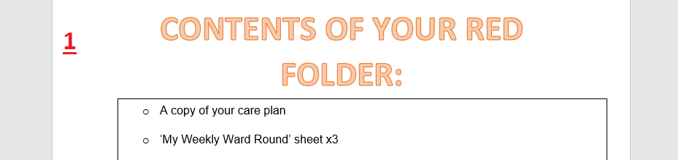
1 x Copy each folder


1 x Copy each folder

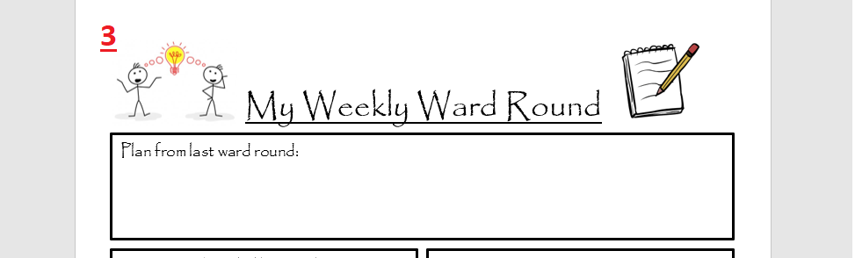
3 x Copy each folder

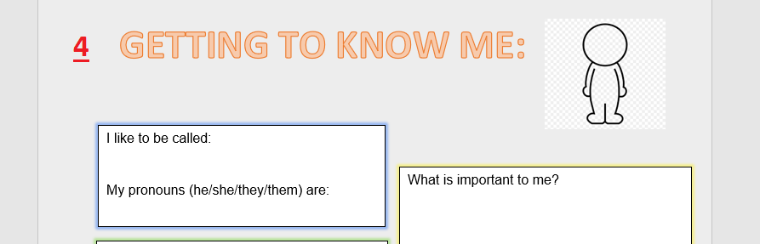
1 x Copy each folder

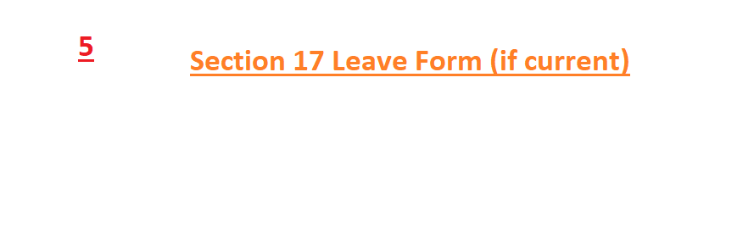
1 x Copy of each active Section 17 leave form in each folder

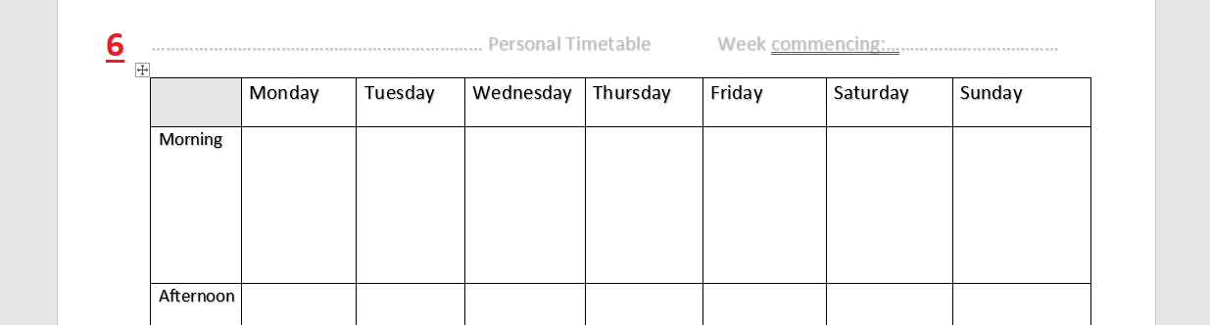
1 x Copy each folder



1 x Copy each folder


1 x Copy each folder as relevant to MHA status

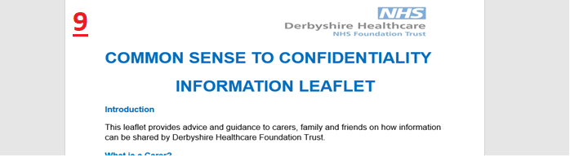
1 x Copy each folder

10
Next add copies of patient information leaflets from Folder B for medications currently prescribed (or being discussed)

11
Ask the patient where they would like to keep their red folder, bedroom or locker?
Next write ‘bedroom’ or ‘patient locker’ on the following poster and display in the patient’s bedroom.

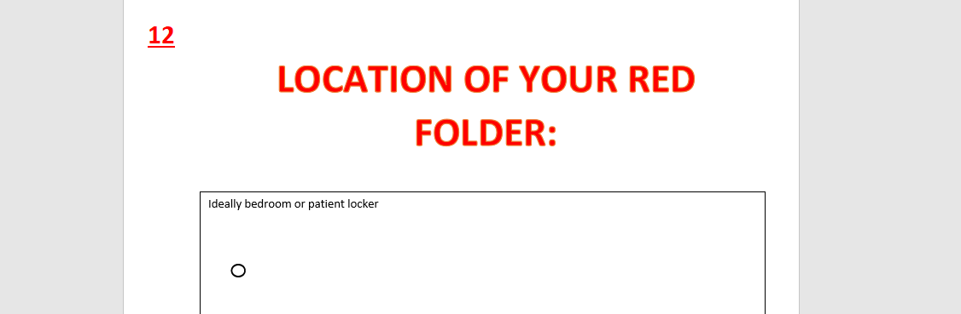
1 x Copy each folder

13 All done well done
Things to remember:
- The contents of these folders are preapproved by the clinical leads
- These folders took some organising, please don’t be the person who uses a last copy without making more, no one likes that person. 20 copies will fit in one pocket comfortably. Either photocopy the last or see W34 Shared Drive.
- Nicola Butler and Mike Sharpe are your points of contact on the ward if you need any help with this.

